TO: Athletic Directors and Boys’ Volleyball Coaches of:
Rockwood Summit, Affton, CBC, Ft Zumwalt East, Fort Zumwalt North, Northwest, St. Francis Borgia, Whitfield

FROM: Mitch Lefkowitz

DATE: March 2nd, 2020

RE: Rockwood Summit High School Boys’ Volleyball Tournament
Rockwood Varsity Boys’ Volleyball Tournament
Saturday, April 4, 2020
Rockwood Summit High School

General Information
- Each school should bring one line judge.
- Practice balls will be provided.
- Team trophies will be awarded for 1st Place and 2nd Place of Championship Bracket.
- The concession stand will be open.
- Absolutely NO food, drink or coolers will be allowed in the gyms.
- Starting time will be 8:00 AM
- There will be a $5.00 admission charge. The cost of the tournament will be pro-rated among the participating schools.
- The first team listed will be the home team.

Pool A (Upper Gym Ct 1) Pool B (Upper Gym Ct2) Time Pool Play

- Northwest 1. Affton 8:00 1 - 3
- Rockwood Summit 2. CBC 9:00 2 - 4
- Fort Zumwalt East 3. Whitfield 9:45 1 - 4
- St. Francis Borgia 4. Fort Zumwalt North 10:30 2 - 3
11:15 3 - 4
12:00 1 - 2

1:30 PM Semifinals 2 of 3 format (25pts, 25pts, 25 if needed)
(Upper Gym Ct 1 – Match A then Match B)
(Upper Gym Ct 2 – Match C then Match D)

3:30 PM Finals 2 of 3 format (25pts, 25pts, 25 if needed)
(Upper Gym Ct 1– Championship Match E)
(Upper Gym Ct 2– Maroon Championship Match F)

If you need additional information, contact Mitch Lefkowitz at Rockwood Summit
High School, 636-891-6836.

Play will be as follows:

- Round Robin competition in each pool.

- Pool play matches will be 2 sets. Rally scoring starting at 6 going to 25 with no cap.

- Warm Ups – For the first match of the day we will follow the normal High School warm-up (5-5-5). For all subsequent matches including playoffs 3-3-1

- Round Robin Set win/loss record will determine the pool play Standings.

- Top Two Teams will advance to Championship Bracket, bottom two to Maroon playoffs.

Teams qualifying for a playoff spot, but tied for a position will follow this tie-breaking procedure:
- Priority 1-A: Results of sets in matches between the tied teams on won/loss record.
  - If still tied, then . . .
    - Priority 1-B: Results of sets in matches between the tied teams on the point spread.
  - If still tied, then . . .
    - Priority 2: Comparison of the point spread based on total round robin play.
  - If still tied, then . . .
    - Priority 3: Flip of a coin.

7. If there are two or more teams tied for the final Championship playoff position
Two Teams Tied:
1. Results of sets in a match between the tied teams on won/loss record
2. 15 point Rally Set, no cap
If 3 teams tie:
- Team with largest overall point differential seeded 1 , second 2, third 3.
  - If ties exist among point differentials, a coin flip will be used to issue seeds
  - 15 point rally set between seeds 2 & 3 – Loser places 4th in pool winner plays 1 seed.
  - Winner finishes as 2nd in pool, Loser places 3rd in pool

8. Semi Finals- match play with best 2 of 3 sets format (25, 25, 25pts if needed NO CAP)
9. CHAMPIONSHIPS - (25, 25, 25 if needed NO CAP)
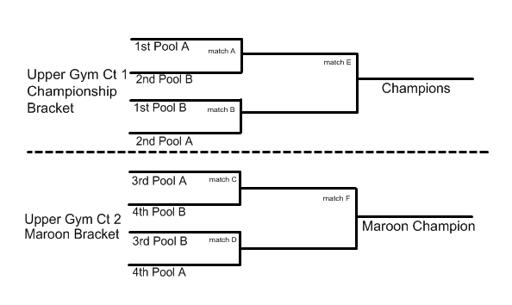

TO: Athletic Directors and Boys’ Volleyball Coaches of:
Rockwood Summit, Northwest, Fort Zumwalt North, Metro East Lutheran, Fort Zumwalt East, Affton, Bayless, Chaminade

FROM: Mitch Lefkowitz

DATE: March 2, 2020

RE: Rockwood Summit Boys’ Volleyball Tournament

Please scan/email a varsity boys’ volleyball roster to Jennifer Schade at 636-861-7717 by March 27th , 2020 so that we may produce a program for our 2020 tournament.

lefkowitzmitch@rsdmo.org (Activities Director)

schadejennifer@rsdmo.org (Activities Secretary)

